

**UNIVERSITY OF GREENWICH**  
COMP1786 – Mobile Application Design AndDevelopment

Logbook

|  |  |
| --- | --- |
| Student name | Nguyen Nhat Khang |
| ID number (00xxxxxxx) | 001353323 |
| Lecturer/Tutor name | Nguyen Dinh Ho |
| Student submission date | November 22, 2023 |

Table of Contents

No table of contents entries found.

**COMP** **1786 Logbook Upload Template**

1. **Exercise 1: Develop a simple calculator**
   1. **Basic information**

|  |  |
| --- | --- |
| 1.1 Student name | **Name:** Nguyen Nhat Khang  **Login id:** 001353323 |
| 1.2 Who did you work with? Note that for logbook exercises you are allowed to work with one other person as long as you give their name and login id and both contribute to the work. | **Name:** Huynh Phan Thai  **Login id:** 001353466 |
| 1.3 Which Exercise is this? Tick as appropriate. | * Exercise 1 * Exercise 2 * Exercise 3 |
| 1.4 How well did you complete the exercise? Tick as appropriate. | * I tried but couldn't complete it * I did it but I feel I should have done better * I did everything that was asked * I did more than was asked for |
| 1.5 Briefly explain your answer to question 1.4.  Without any explanation/justification, your scores will be deducted. | In this simple calculator application exercise, I did everything asked. |

* 1. **Exercise answer**

## **Screen shots demonstrating what you achieved.**

**GUI of calculator**

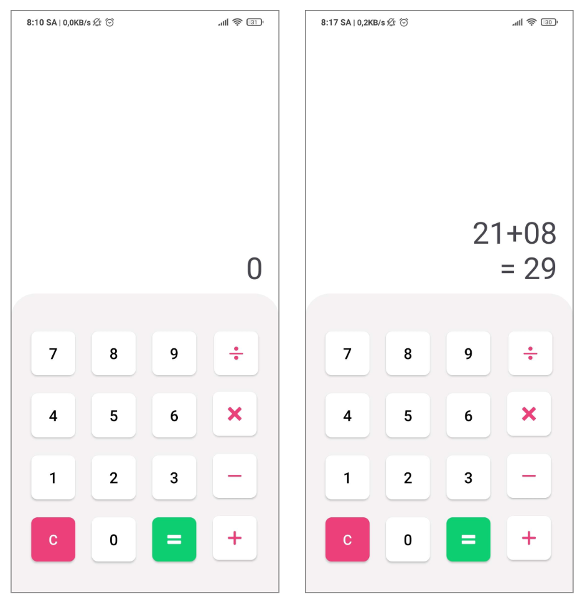

Figure 1 Calculator's GUI

## **My code wrote**

|  |  |
| --- | --- |
| File name: MainActivity | |
| Code | Explanation |
| package com.cyberspace.cybercalculator;  import androidx.appcompat.app.AppCompatActivity;  import android.os.Bundle; import android.view.*WindowManager*; import android.widget.Button; import android.widget.ImageView; import android.widget.TextView; import android.widget.Toast;  import java.util.ArrayList; import java.util.Arrays; import java.util.*List*;  public class MainActivity extends AppCompatActivity {   private Button btn_0, btn_1, btn_2, btn_3, btn_4, btn_5, btn_6, btn_7, btn_8, btn_9, btn_delete;  private ImageView btn_plus, btn_division, btn_multi, btn_minus, btn_equal;   private TextView txt_result;  private String operator, string_calculate;   @Override  protected void onCreate(Bundle savedInstanceState) {  super.onCreate(savedInstanceState);  setContentView(R.layout.*activity_main*);   getWindow().setFlags(  *WindowManager*.LayoutParams.FLAG_LAYOUT_NO_LIMITS,  *WindowManager*.LayoutParams.FLAG_LAYOUT_NO_LIMITS  );   this.operator = this.string_calculate = "";   MapComponent();  EventListener();  ButtonNumberListener();  ButtonOperatorListener();  }   public void MapComponent(){  this.btn_0 = findViewById(R.id.*btn_0*);  this.btn_1 = findViewById(R.id.*btn_1*);  this.btn_2 = findViewById(R.id.*btn_2*);  this.btn_3 = findViewById(R.id.*btn_3*);  this.btn_4 = findViewById(R.id.*btn_4*);  this.btn_5 = findViewById(R.id.*btn_5*);  this.btn_6 = findViewById(R.id.*btn_6*);  this.btn_7 = findViewById(R.id.*btn_7*);  this.btn_8 = findViewById(R.id.*btn_8*);  this.btn_9 = findViewById(R.id.*btn_9*);   this.btn_plus = findViewById(R.id.*btn_plus*);  this.btn_division = findViewById(R.id.*btn_division*);  this.btn_multi = findViewById(R.id.*btn_multi*);  this.btn_minus = findViewById(R.id.*btn_minus*);   this.btn_equal = findViewById(R.id.*btn_equal*);  this.btn_delete = findViewById(R.id.*btn_delete*);   this.txt_result = findViewById(R.id.*txt_result*);  }   public void ButtonNumberListener(){  *List*<Button> btn_numbers = new ArrayList<>(Arrays.*asList*(  this.btn_0, this.btn_1, this.btn_2, this.btn_3, this.btn_4,  this.btn_5, this.btn_6, this.btn_7, this.btn_8, this.btn_9  ));   for (Button btn_number : btn_numbers) {  btn_number.setOnClickListener(view -> {  Button number = (Button) view;  String input_num = number.getText().toString();   this.string_calculate += input_num;   this.txt_result.setText(this.string_calculate);  });  }  }   public void ButtonOperatorListener(){  *List*<ImageView> btn_operators = new ArrayList<>(Arrays.*asList*(  this.btn_plus, this.btn_division, this.btn_multi, this.btn_minus  ));   for (ImageView btn_operator : btn_operators) {  btn_operator.setOnClickListener(view -> {  ImageView operator = (ImageView) view;  String str_operator = operator.getTag().toString();  if(this.string_calculate.equals("")){  this.string_calculate = "0";  }   if(this.operator.equals("")){  this.string_calculate += str_operator;  } else {  String current_operator = this.string_calculate.substring(this.string_calculate.length() - 1);  if(current_operator.equals("+") || current_operator.equals("-") || current_operator.equals("x") || current_operator.equals("/"))  {  this.string_calculate = this.string_calculate.substring(0, this.string_calculate.length() - 1) + str_operator;  } else {  this.string_calculate = Calculator() + str_operator;  }  }  this.operator = str_operator;  this.txt_result.setText(this.string_calculate);  });  }  }   public void EventListener(){  this.btn_delete.setOnClickListener(view -> {  this.HandleDelete();  });   this.btn_delete.setOnLongClickListener(view -> {  HandleDeleteAll();  return true;  });   this.btn_equal.setOnClickListener(view -> {  this.HandleCalculator();  });  }   private void HandleDeleteAll(){  this.txt_result.setText("0");  this.string_calculate = "";  this.operator = "";  }   private void HandleDelete(){  if(!this.string_calculate.equals("")){  String operator = this.string_calculate.substring(this.string_calculate.length()-1);  if(operator.equals("+") || operator.equals("-") || operator.equals("x") || operator.equals("/")){  this.operator = "";  }   this.string_calculate = this.string_calculate.substring(0, this.string_calculate.length() - 1);  if(!this.string_calculate.equals("")){  this.txt_result.setText(this.string_calculate);  } else {  this.txt_result.setText("0");  }  } else {  this.txt_result.setText("0");  }  }   public void HandleCalculator(){  if(!this.string_calculate.equals("")){  this.txt_result.setText(this.string_calculate + "\n= " + Calculator());  this.string_calculate = "";  this.operator = "";  }  }   private String Calculator(){  if(this.operator.equals("")){  return this.string_calculate;  }  try {  int index_operator = this.string_calculate.lastIndexOf(this.operator);  Double num_one = Double.*parseDouble*(this.string_calculate.substring(0, index_operator));  Double num_two = Double.*parseDouble*(this.string_calculate.substring(index_operator+1));   String result = "";  switch (this.operator){  case "+": result += (num_one + num_two); break;  case "-": result += (num_one - num_two); break;  case "x": result += (num_one * num_two); break;  case "/": result += (num_one / num_two); break;  }   return PrettyNumber(result);   } catch (Exception ex){  this.string_calculate = "";  this.operator = "";  Toast.*makeText*(this, "Invalid input", Toast.LENGTH_LONG).show();  return "";  }  }   private String PrettyNumber(String num_str){  int index_dot = num_str.indexOf(".");  if(index_dot != -1) {  String[] str_arr = num_str.split("\\.");  if (str_arr[1].length() == 1 && str_arr[1].charAt(0) == '0') {  return num_str.substring(0, index_dot);  }  }  return num_str;  } } | - Declare variable  - Configure full screen mode  - Call functions to setup application  - Map components in the view to declared variables  - Add event listener for buttons, instead of manually attaching events to each node, I created a button array and loop through each element and attached the event to it. |

1. **Exercise 2: Create an android app allowing users to view images**
2. **Exercise 3: Use Android Persistence to store data**
3. **Basic information**